Logging

A log is a record of the events occurring within an organization’s systems and networks. Logs are composed of log entries; each entry contains information related to a specific event that has occurred within a system or network." (Kent & Souppaya, 2006)
"Logging is a fundamental requirement of any system, as things will go wrong, we need a way to diagnose and isolate the cause. No matter what operating system you use one of the best locations for diagnostic information is the system log." (Eaton, 2003).
There are many different types of logs – many applications produce logs, as well as most servers especially web servers, email servers and database servers. There are even specialist tools designed to analyse web logs due to the fact that said logs produce very valuable information about both traffic and also security incidents. Some database servers use their logs for backups, replication and resilience. Security appliances and tools in particular rely heavily on logging – especially tools such as intrusion detection systems and SIEM (Security Information and Event Management which will be reviewed later in this lecture cast). Virtually all log messages consist of a timestamp, a hostname and an application (program name) field, as well as some indication of the status (see later).
The syslog system started as part of the Sendmail email application and was adopted as part of the core system logging on the BSD (Berkeley Software Distribution”) operating system. In the early 2000s, this led to a number of RFCs (Request for Comments.) that started to formalise syslog as a standard – eventually, it led to RFC 5424 in 2009 which defined the RFC protocol.

Nowadays most Unix derived systems (BSD, Linux) store their logs in the /var/log directory. All these files are text files (or archives, see later) so can be read by a standard text reader – although there are a number of dedicated tools.

Logs are grouped into various sets. There is:
- /var/log/syslog or /var/log/messages, which tend to hold all the system level messages.
- /var/log/auth.log and /var/log/secure both keep a history of logins and authentications (both successful and failed attempts).
New Kali uses systemd’s journal instead. View logs for current boot only:
sudo journalctl -b
of logins and authentications: sudo journalctl -u systemd-logind
There are different log messages regarding boot, kernel generated message, mail server and so on.
There are various other logs including web servers (usually /var/log/httpd) databases (e.g. /var/log/mysqld.log) and ftp servers (var/log/ftp.log) amongst many others – but these will depend on the services installed and applications used.
A key log management utility is logrotate which is used to manage the number of instances of each log to keep, when to create a new log file, when and how to archive old logs, and even whether to email logs to another destination. The many varied configuration options are kept in a /etc/logrotate.conf file. Detailed information about the logrotate command as always can be obtained via the standard Unix MAN command.
logrotate manages:
- Log rotation frequency
- Number of retained logs
- Compression & archiving
- Post-rotate actions (e.g. reload services)
Modern Kali uses systemd journal for most core logs.
Journal logs are managed by:
journalctl --vacuum-time=7d
journalctl --vacuum-size=500M
How to check logrotate configuration on Kali:
sudo less /etc/logrotate.conf
Microsoft Windows also maintains a number of logs, but these are managed differently than on Unix –like systems. As discussed above the operating system and various applications generate logs. However, on a Windows system, the default application used to access logs is the event viewer, which is part of the administrative tools group. This will be dealt with in our later discussion on viewers.

Log entries are classified by type such as:
- bullet
Error
- bullet
Information
- bullet
Warning
- bullet
Success audit and failure audit for Windows systems
- bullet
Emergency
- bullet
Alert
- bullet
Critical
- bullet
Error
- bullet
Warning
- bullet
Notice
- bullet
Info
- bullet
Debug for MacOS and Linux systems
As the names suggest the highest priority are critical and emergency, the lowest are warnings, info and debug. Many applications have options that dictate the level of logging that they will generate, and most viewers can also filter messages by status type.

As discussed previously, Unix logs can be viewed in any standard text editor but there are a number of built-in utilities that can also be used. The classic command-line log viewing utility is tail – it has the "–f" option which allows the viewer to follow log updates. There are also variations. For example, colortail which does a similar job, but colours the logs based on pattern matching of the status type.

The screenshot in fig 1 shows the Lnav log navigator for Mac, which offers similar facilities to colortail, and much more besides.
Again, as mentioned above the default viewer on windows is event viewer. Unlike utilities such as tail, event viewer has a navigation pane that allows the user to select which logs to view, as shown in figure 2 below.
One of the key questions around logs is where to store them – locally, remotely or both. It is very useful to have logs on a machine that you need to investigate. However, sometimes a compromised machine may not be available or logs may have been deleted (by an attacker). Therefore, it is imperative that there are other locations to access logs from.
As discussed logrotate has an option to email logs to another location which is basic but a useful fallback. Most implementations of the syslogd (syslog daemon) have the option to receive and forward syslog messages to and from other daemons on other machines. This means that logs can be written to multiple machines if required. This option supports both UDP and TCP messages. The latter is preferred to ensure messages are received and written. Many modern solutions recommend that a central, secure syslog machine is set up to hold copies of syslogs from all machines in a system. This approach will be discussed in a later section.

Logging Tools
As discussed in the previous section Syslogd is the standard daemon installed on most Unix-like machines and although it does a good basic job it has been superseded by more modern alternatives, such as those we will discuss here.

Syslog-ng
Syslog-ng is probably the closest to the original daemon, and in many cases, it is a drop-in replacement. The main benefits are:
- bullet
The default use of TCP links
- bullet
Better filtering
- bullet
More comprehensive routing options via templates
- bullet
More accurate timestamps
It is available as an open-source (LGPL version) and as a commercial supported version. It is available either as an option or as standard in several GNU/Linux distributions.

Nagios
Nagios is an open-source monitoring solution. Its name is a typical open-source recursive definition that supposedly stands for 'Nagios Ain't Gonna Insist On Sainthood' (it is based on an older tool called NetSaint). Nagios is a log aggregation and monitoring application. It is usually hosted on a Linux server. Not only can it aggregate and monitor logs from virtually every other server available, it can also monitor hardware and network infrastructure as well via a large selection of agents and plug-ins. It can even use SNMP (simple network management protocol) to gather data from even the most basic appliances. It can write log data to various database servers and display data as web pages or text alerts, as shown in figure 3.

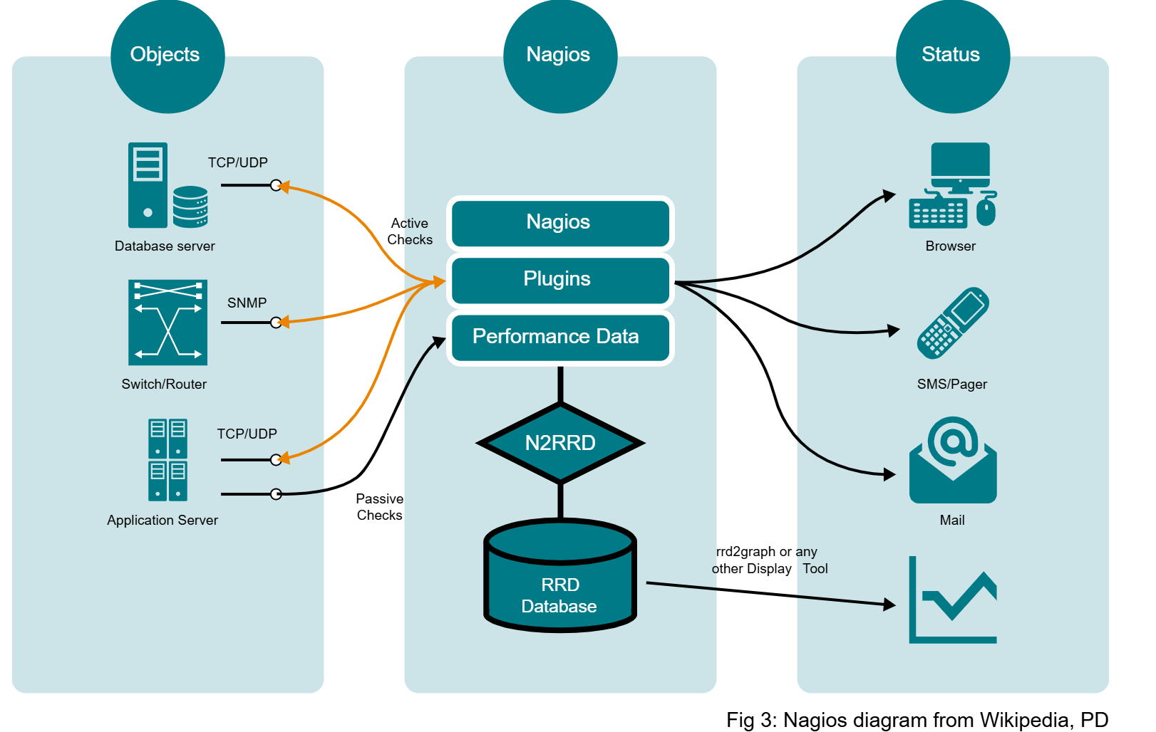

Snort
Snort's main function is as an open-source intrusion detection/ prevention system. It can run in three modes:
- 1
1
Sniffer (reading network packets and displaying them on the console)
- 2
2
Logger (capturing packets and logging them to disk)
- 3
3
Network intrusion detection system (NIDS – monitor network traffic and analyse it against rule set(s) and take appropriate action)
In this latter mode, snort can detect OS fingerprinting and various penetration testing scans – as were discussed previously. Snort is often used in combination with other third-party open-source tools – such as Sagan (a log analysis tool) to create a SIEM like solution. Some solutions also run multiple instances of snort simultaneously – see (Clark, n.d.) in the references.

Log Analysis Tools Transcript
As described in previous sections, logs consist of thousands of lines of text that contain IP addresses,
possibly host names, time stamps and a status message. Although this information is crucial for many
business functions including marketing, sales and not least security, trawling through thousands of lines
of text is not the most time-efficient nor productive method of analysis. Fortunately, there are a number
of both freely available and commercial tools that can perform multiple types of analysis – a few
examples are given in this section.
One of the earliest weblog analysis tools was webalizer – it is a specialist tool used to produce
daily, weekly, monthly and yearly graphical reports from the access logs of common web servers such
as apache. It can read various formats, as well as being able to read archived (zipped) logs. An
example of a typical report page is shown in figure 4. The HTML page shown was actually produced by an application known as awffull – which is a more modern fork of webalizer.
ELK is not a single application, it is an acronym based on the core applications that comprise the stack
– the default applications are elasticsearch, logstash and kibana. More recently other applications have
been added and the expanded stack is known as the Elastic Stack.
Elasticsearch, as the name suggests is a free text search engine designed to search JSON (JavaScript
Object Notation) formatted data files. Logstash is a data logging and analysis tool that complements
elasticsearch and Kibana is one (of a number) of graphing and display applications.
Elastic stack has also used the product stack to create their own SIEM (see the references for a link).
Security Information and Event Management (SIEM) is the go-to tool for modern security professionals.
The aim is to provide an application that can pull together all sources of security alerts and events into
one place – the SIEM platform. The term was introduced in a Gartner report in 2005 by researchers
Williams and Nicolett (Vielberth & Purnul, 2018). A UML diagram from the same authors is shown in
figure 5. As with many buzzwords, the acronym has been overused and abused but essentially it describes a system that can correlate, aggregate and analyse logs. In addition, it should be able to apply rules to detect and alert on common attacks – some of this information may come from other
sources (e.g. snort). (Swift, 2010) produced a report which listed a number of recommended features,
plus a list of industry leaders. A SIEM may be based on-premises, in the cloud or provided by a third
party as part of a SOC (Security Operations Centre). One of the most popular SIEM providers is Splunk
who make their product available as a limited functionality free version (only 500MB of logs a day can be ingested) or the full, unlimited enterprise version.

Digital Forensics
When investigating a security breach, there is often a need to utilise digital forensic techniques to look
for evidence. Campbell (2016) definition states "digital forensics (also referred to as computer
forensics) is a specialisation within the security industry that converges with traditional forensic science.
It is concerned with the recovery of digital evidence from storage media, computer systems, electronic
devices and social media platforms" (Campbell, 2016). NIST has also published a special publication
about the discipline (SP-800-86). It defines 4 phases to the process – collection, examination, analysis
and reporting (see figure 7). Collection is the general process of identifying, obtaining, labelling and
identifying the data. Examination involves forensic processing of data, extracting suitable and pertinent
data while maintaining the integrity of the system. Analysis looks at investigating and drawing relevant
information from the data, and finally, reporting summarises conclusions while stating the processes
and procedures used to reach those conclusions. Like every other security process, there are a number
of standards for forensic investigations, but it is particularly important that these are adhered to for
digital forensics as often the evidence discovered may eventually form part of legal proceedings against
the perpetrator. This section will discuss the NIST standard recommendations.
Digital forensics tools can be used for many things: operational troubleshooting such as resolving
network issues; verifying asset management databases and even testing new applications; log
monitoring is not just for security incidents, as described previously the data may be useful to sales and
HR as well; forensic tools are especially useful for data recovery so accidentally deleted or damaged
files; they can also be used for data acquisition and archiving – for example when an organisation is
about to retire an appliance, or an employee leaves forensic tools can be used to back up all the device
or individual data to be used later – in line with GDPR of course.
The final point is probably the most important – due diligence should be ensured in any forensic
investigation. The Association of Chief Police Officers in the UK (ACPO) produced a guide to check that
the process and due diligence is adhered to – it is discussed in (Campbell, 2016) and briefly reviewed
here. The key points are: Always make a backup of original data and work on that – the original must be left untouched wherever possible to verify that the system will be admissible as evidence;
anyone working on the original system should be a 'competent person' and able to justify and defend any
actions and processes undertaken; all investigations should be recorded, auditable and repeatable by a third party; there should be a case officer who is the responsible person who is well versed in legal and evidential processes and procedures.

Forensic Tools
As discussed, when reviewing the checklist, a security breach can take many forms. There are whole suites of applications available to aid in forensic investigations – running the gamut (HITEH, HODOOD) from enterprise-level commercial tools to well established and respected open source suites.
The tools should cover all eventualities – for example a breach may be:
- Delivered as an email payload
Launched when the user opens the mail or clicks on a link.
- A worm delivered over the internet.
- A disgruntled employee
- Exploiting a vulnerability in some system component.

A full forensic investigation requires that the investigation team evaluate every part of a system. So:

- There is a need to examine the RAM of an active system as well as the swap space and the normal storage areas of a disk looking for evidence of an attack;
- 2
2
There is a need for tools to scan storage media looking for deleted files (such as emails or zip files that may have contained a payload);
- 3
3
Existing applications need to be checked to ensure that they haven’t been replaced by malware;
- 4
4
Existing systems should be scanned and checked to ensure all components are patched up to date and there are no obvious security vulnerabilities;
- 5
5
Logs should be copied and examined looking for any evidence of how and when the attack occurred.

Commercial
–
FTK (Forensic Toolkit) is a commercial suite of applications used to scan storage media looking for deleted items (such as emails), text strings and other document fragments. In addition, it can create a bit level image for archiving or investigation purposes. Encase is another well respected commercial forensic toolkit used to investigate and catalogue data held on storage media.

Open Source
–
Open Source tools are heavily and extensively used in security and forensic investigations. Live distributions such as Kali can be used for forensic purposes as well as for hacking purposes, and there are dedicated collections such as Caine that is designed for forensics specifically. The benefit of live distros is that no installation is required which means that the machine under investigation is not modified. Caine has tools that can examine both Windows and Linux/Unix systems including scanning the registry, file systems and storage media. It also has tools such as wireshark that can be used to investigate stored packet dumps offline. Most Linux systems have tools that can check the processes running, including who initiated them and which libraries they use. This can go a long way to determine if malware is masquerading as innocuous (بئ ضرر) utilities or system components.

Windows
–
Sysinternals is a suite of Windows utilities created by Mark Russinovich but now owned by Microsoft that provides a comprehensive toolkit that can be used for advanced diagnostics and troubleshooting such as monitoring and diagnosing active processes, investigating system libraries and detecting hidden malware.

Logging
–
As discussed extensively in earlier sections, logging is an essential part of any security investigation and the recommendations made earlier still apply. Logs should be replicated and written to a central logging server, preferably a SIEM server. Although enterprise solutions can be expensive, there are a number of options available for smaller businesses. For example, the free edition of splunk can be used offline for forensic investigations without the usual 500MB limit on log size.

Monitoring
–
A monitoring solution such as Nagios can be very useful as well – because it monitors infrastructure hardware as well as logs it can be used to generate alerts caused by various attacks include DoS (denial of service) utilisation peaks.

IDS
–
Finally, a network IDS such as snort can be used to detect patterns of common attacks and generate alerts that will act as early warnings.

IPv6 vs. IPv4 Challenges
As discussed in a previous session, many people believe the future of the internet is based on a move to IPv6 addressing. Others challenge this, citing that IPv6 has been available for over twenty years and yet is still not used by the majority of ISPs and Servers ( Google state that worldwide use is over 30%, but this is not exclusive - i.e. most of these sites run IPv4 as well).
Why has adoption been so slow? There are several blockers, as detailed in table below:
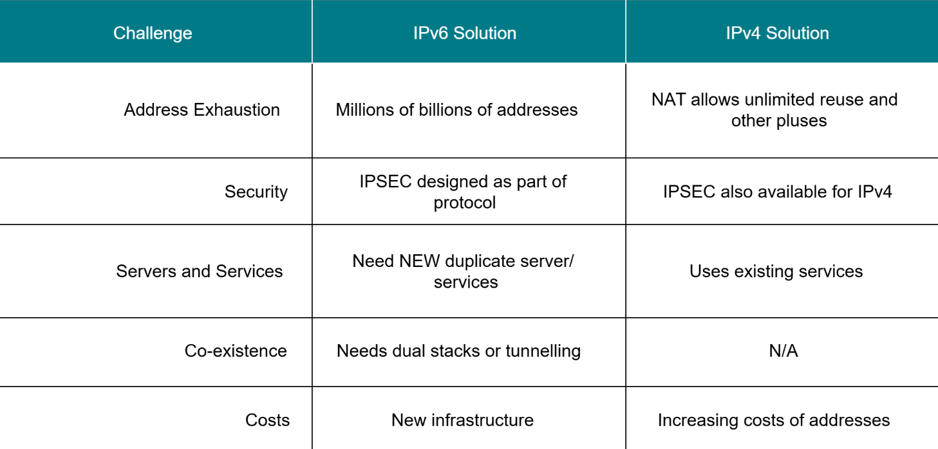

IPV6 has not generally implemented so, that means vulnerabilities have not been discovered yet.
While DHCP implementation is not necessary for IPV6 addressing (using SLAAC = Stateless Address Autoconfiguration); it is used for many services such as DNS parameters. In other hand DHCP isn’t needed to give IPv6 devices an IP address, but it is used to give them important settings like DNS.
Dual stack is required for co-existing, as well as CPU and network overhead, security requirements and extra configurations.

Secure Protocols
When the basics of the Internet were being created (circa late seventies) the world of networking was a simpler, more trusting place. Although we have discussed how the first security breaches occurred in the sixties, there was no security industry and thus there seemed to be no real drivers for secure protocols in the emerging internet stack. However, as business began to adopt the internet as an underlying conduit for business, and even more as e-commerce began to take off it became increasing apparent that the core internet protocols needed to be secured.

As far back as 1988 the NSA (National Security Agency – US) was sponsoring research into secure protocols which eventually led to the IETF publishing a number of RFCs that initiated IPsec as a protocol. IPsec was initially conceived as part of the IPv6 replacement for IPv4 but due to the delays in adopting IPv6 it was adapted to work with the existing IPv4 protocol.

IPsec was designed to provide...
- 1
1
Confidentiality
- 2
2
Integrity
- 3
3
Availability
(CIA) ...by using a two part solution – the Authentication Header (AH) and the Encapsulating Security Payload (ESP).

As the name suggests AH authenticates but it does not encrypt – so it can provide integrity by the use of a cryptographic hash based on the immutable fields of the IP header.

ESP does encrypt – so it can provide confidentiality, integrity and even a measure of availability.

As the name suggests ESP encrypts the entire payload, so the message and the original header are encrypted as well.

IPsec can be used in 2 modes – either transport or tunnel mode, as the following figure illustrates.
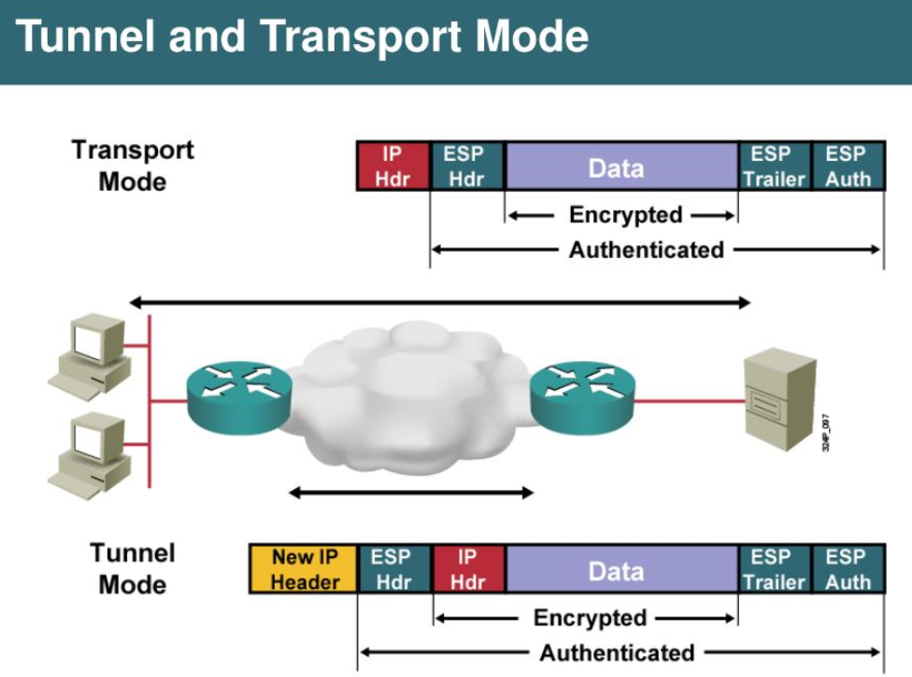
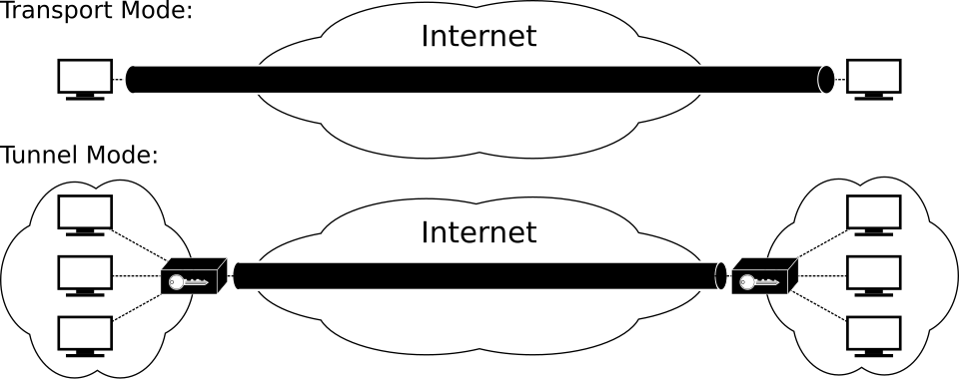
Transport mode can use AH or ESP or both features of the protocol. AH will ensure that the originating IP address cannot be 'spoofed', ESP will encrypt the payload. The second mode – tunnel mode – is effectively the familiar VPN (Virtual Private Network) connection. In tunnel mode an entire packet is encrypted and encapsulated in another packet before it is transmitted.

Secure Protocols: DNS
The Domain Name System (DNS) is a fundamental component of the Internet as we know it today. It provides the function of the 'internet telephone book’ - looking up IP addresses (both IPv4 and IPv6) from the URL (uniform resource locator) used by most people as the human friendly name of a web site. It is a hierarchical system, based on top level domain (TLD) servers that manage the .org, .com and suchlike domains. It is a progression from the original hosts.txt solution which was based on a simple text file that held a list of IP addresses and names. The nature of the DNS system means that a new URL is propagated around the servers (usually within 24 – 48 hours) so that any query worldwide can find an address lookup. Most client machines use resolvers to query a local name server that has the ability to escalate a query all the way up to the TLDs if required.
Example (step by step)
When you visit www.example.com:
- Your computer asks a DNS resolver
- Resolver asks a Root server
- Root replies: “.com is handled here”
- Resolver asks the .com TLD server
- TLD replies: “example.com is handled by these name servers”
- Resolver asks the authoritative server → gets the IP
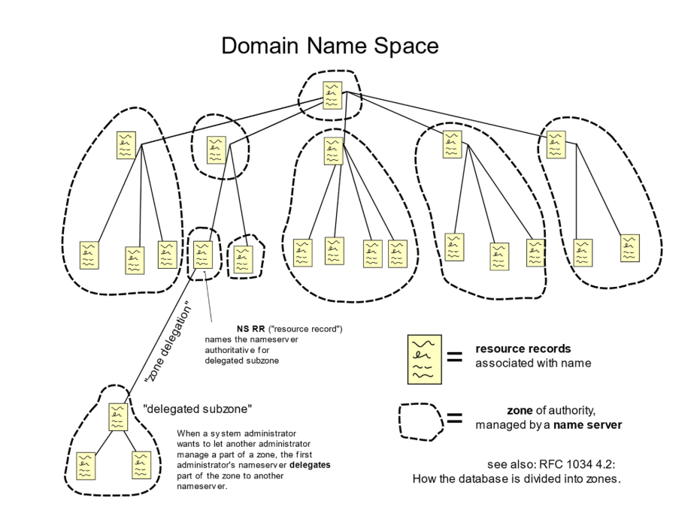

Bellovin (1995) wrote a paper that documented how DNS could be used to stage system break-ins, and he also recommended possible solutions to the problem. Although the IETF published the first RFC in response to the paper in 1997, and the first solution was ready by the end of the nineties, its key handling mechanism was found to be not scalable and so had to be revisited and redesigned. The first deployments of DNSSEC happened in a few localised countries by 2007. The first root servers started to use DNSSEC in 2010.
DNSSEC does not encrypt DNS messages. Instead it is a cryptographic authentication mechanism, like AH of IPsec. Its main purpose is to assure the integrity of DNS responses and records and also to provide assurance that certain domains do not exist. It can also be used to assure the validity of public keys, such as those used in IPsec.

DNSSEC secures DNS by using cryptographic signatures and a hierarchical chain of trust to verify the authenticity and integrity of DNS data.
Secure Shell (SSH) was developed in 1995...
...to replace a variety of insecure protocols used on Unix systems including telnet, rlogin and rexec. It provided a secure tunnel that not only allowed remote login but also allowed a variety of other protocols to be run over it. It uses a client server model, where the SSH client connects to a SSH server on the remote device. It uses cryptographic keys to encrypt the network connection and can either authenticate via public-private key pairs or via simple passwords.

Some implementations of SSH even use public - private key pairs and passphrase security on the private key. Most modern implementations of the SSH protocol use the open source OpenSSH package. OpenSSH is also another mechanism of creating a VPN, certainly within privately owned nodes.

Secure Protocols: HTTPS
Hypertext Transfer Protocol Secure (HTTPS) is the secure version of the standard HTTP web browser/ server protocol. It uses either SSL/ TLS (secure socket layer/ transport layer security) to encrypt the layers below the application protocol layer which means that the entire message including the transport and internet layers is encrypted. There have been four versions of the hypertext transfer protocol (HTTP) - v1.0 which used a new connection for every resource request, the major enhancement in version 1.1 was keep alive requests where a connection could be reused for multiple requests, reducing latency. HTTP v2.0 (also known as HTTP/2) is based on a protocol created by Google known as SPDY which was designed to compress and multiplex web content, as well as operate over TLS. Nonetheless, most web sites defaulted to sending data over HTTP - I.e. non-secure, even if a secure version existed. In 2011 a browser plug-in called HTTPS Everywhere was released that was designed to force websites to default to secure communications to avoid problems such as MITM (man in the middle) and cookie leakage attacks. The latest version of HTTPS – version 3.0 also known as HTTPS/3 is once again based on a Google designed protocol – this time QUIC (initially an acronym for Quick UDP Internet Connections). QUIC marks a major move to UDP away from TCP, moving the flow and reliability control further up the stack. In addition, it defaults to initiating the security handshake at the start of every connection – based on an assumption that most will be secure (HTTPS).
A typical PKI setup is shown in the following figure:
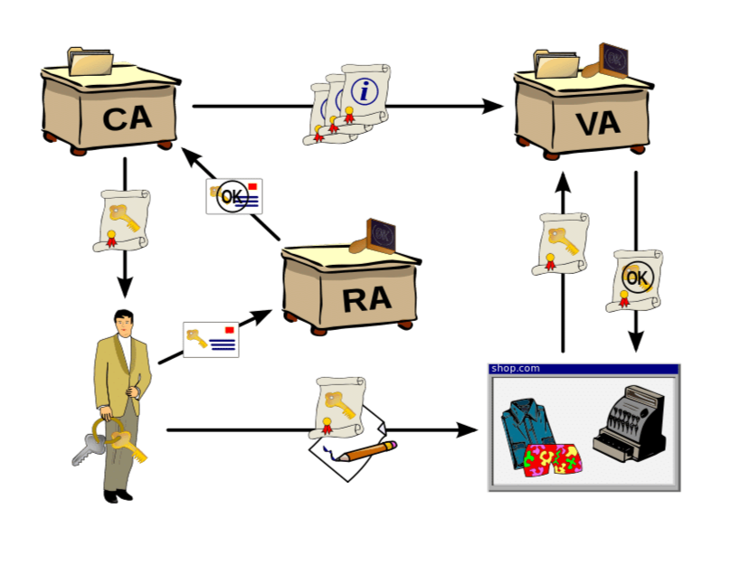
- It depends on a Registration Authority (RA) accepting requests for certificates and validating the requester.
- 2
2
A Certificate Authority (CA) generates, stores and issues the certificates.
- 3
3
The most common standard for the certificates is X.509.
- 4
4
These certificates securely map keys to individual entities.
- 5
5
There is also usually some kind of central directory where keys are securely stored and indexed.
- 6
6
Many CAs are often commercial trusted third parties such as Symantec.

An alternative system is known as the web of trust that uses self signed certificates, signed using mechanisms such as OpenPGP or GnuPG and issued via secure email distribution. More recently blockchain technology has being promoted as a way of offering distributed PKI (DPKI) - a more secure way of distributing keys.
The web of trust is a decentralised trust model where users sign each other’s self-signed certificates using tools such as OpenPGP or GnuPG, with trust distributed through personal relationships rather than a central authority.
(Allen et al, 2015) and (Huang, 2019) discuss some of the problems of PKI and why DPKI should be considered as an alternative, see the references for the full articles.
As these articles attest, PKI is not fool proof or un-spoofable – there have been many examples of CAs generating certificates under false pretences, or of certificates being hijacked and misused. In addition the core mechanism used in key exchange – the Diffie-Hellman key exchange (DHKE) – has also been compromised as discussed by (Adrian et al, 2015) to allow eavesdropping on supposedly secure messages. Thus issues with PKI can cause issues with all the protocols mentioned.
In addition the cryptographic protocols themselves – SSL/TLS - have also been compromised in various versions.
The problem is that...
...most browsers and web servers support all the protocol versions – from SSL v2.0 up to TLS v1.3. Many of the older versions have been deprecated because of known exploits or vulnerabilities, however because there is nothing on the internet that forces a browser or server to update to the latest supported version of the protocols both have to maintain support for older, vulnerable versions. This has led to a number of 'downgrade' attacks where one side of the link forces the other to use an older, insecure protocol version, allowing the message to be easily decrypted.

There are also attacks that use the compressed nature of modern payloads to expose sensitive information.

Virtual Networking
With the move towards cloud computing and the accompanying increase in virtualised servers networking has also moved into the realm of virtualisation. There are various facets of this transformation, from network function virtualisation (NFVs) to complete software defined network stacks (SDNs). However the fact is that virtual networking is on the rise, along with its obvious benefits and unavoidable risks and pitfalls.

Virtual Networking: NFVs
In hindsight NFVs seems like an obvious progression for the industry. Many network hardware appliances (switches, routers, firewalls, etc.) were based around complex ASICs (application specific integrated circuits) which were difficult to upgrade and/or replace as a business' needs changed. In addition the cost of energy consumption and cooling in data centres became every more important (and difficult) to manage. At the same time, the computing power of general purpose CPUs increased, and it became increasingly cost effective and technically feasible to produce software versions of those dedicated circuits. The rise of virtualised machines and cloud computing sealed the deal – there was a tangible commercial need for software based network appliances.
In 2012 a number of network operators and equipment manufacturers gathered together to form an Industry Specification Group (ISG) to drive the development of NFV appliances.
Some of the application areas that can be addressed by NFVs include:
- bullet
Mobile network nodes: e.g. gateways.
- bullet
Functions contained in home routers and set top boxes to create virtualised home environments.
- bullet
Tunnelling gateway elements: e.g. VPN gateways.
- bullet
Traffic analysis: e.g. QoS measurement.
- bullet
Service Assurance, SLA monitoring, Test and Diagnostics.
- bullet
Application-level optimisation: e.g. CDNs and Cache Servers.
- bullet
Security functions: e.g. Firewalls & virus scanners.
Increasingly NFVs are thought of as part of a NFVI (NFV Infrastructure, which could consist of both virtual and physical nodes) and a management and orchestration layer (known as NFV-MANO). A typical high-level network architecture is shown below. Today NFVs are produced by most manufacturers including Cisco, Juniper and even VMware. Many of the security considerations are the same as those of any typical cloud (or virtualised) infrastructure.
The following table shows a summary of possible vulnerabilities and best practices (Lal et al, 2017).

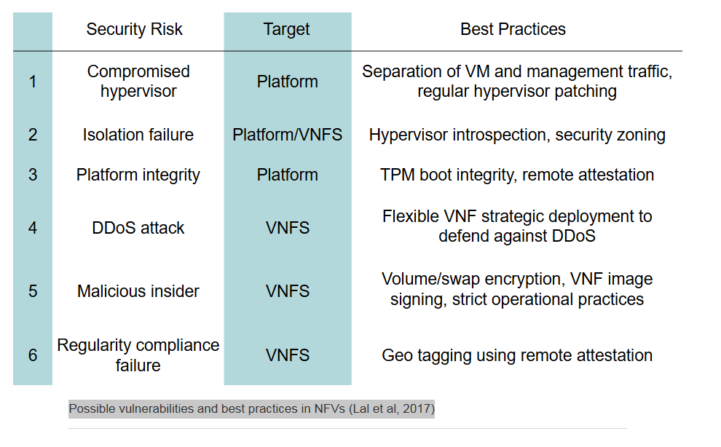

Software Defined Networking (SDN)
is a next generation approach to network management, whereas traditional network devices, for example routers, separate the data and control planes within an appliance to be able to manage the various hardware aspects of that device, SDN applies that paradigm to an entire network infrastructure.
This is shown in the following figure (Rawat & Reddy, 2017):
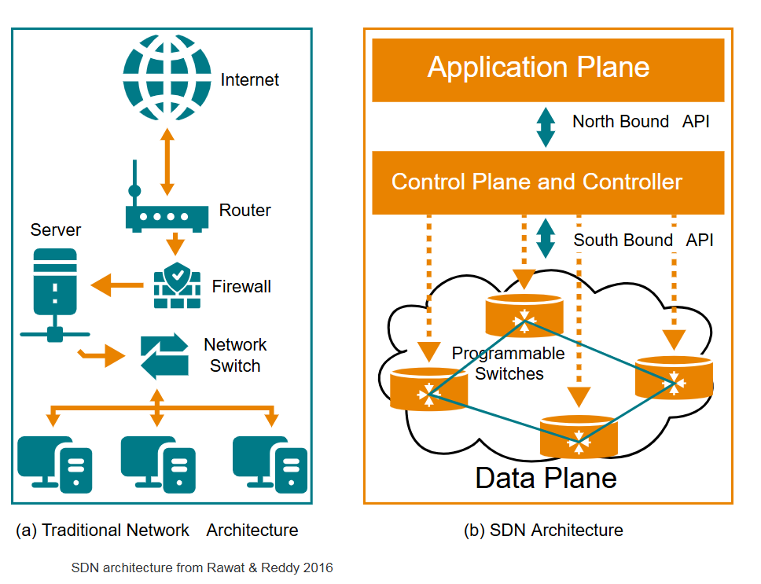
The figure shows that SDN can be decomposed into 3 layers – an application plane, a control plane and a data plane.
It provides the advantages of NFVs (energy and hardware efficiency and flexibility) together with the flexibility of a user programmable architecture. In addition, it can work with NFVs, traditional programmable hardware devices or a combination of both. Just as in a traditional router the data plane is responsible for forwarding data packets on to their destination based on rules decided by the control plane.
The data plane consists of...

...components such as the open vswitch, openflowj or physical switches.

What is OpenFlowJ?
OpenFlowJ is a Java implementation of the OpenFlow protocol (SDN protocol).
It lets developers build SDN (Software-Defined Networking) controllers or applications in Java that can:
- talk to network switches
- send OpenFlow messages
- control traffic flows programmatically

The control plane is...

...again very similar to that in a physical router – it makes decisions on where packets should be routed based on rules and configuration directives – the difference is that in a SDN system the control plane controllers are programmable. The control plane also provides the APIs the other planes use to communicate.
The application plane provides...

...the management, monitoring, business and security applications that direct the other controllers. This plane will typically host network applications such as IDS, netflow, and kubernetes.

NetFlow
A network monitoring technology (originally by Cisco) that collects and exports traffic metadata such as:
- source/destination IP
- ports
- protocol
- amount of data
👉 Used for traffic analysis, performance monitoring, and security detection
(not for carrying traffic itself).

Kubernetes
An open-source container orchestration platform that:
- deploys
- scales
- manages containerised applications
👉 Used to automate container operations in cloud and microservices environments.

One-line memory hook
- NetFlow = observe network traffic
- Kubernetes = manage containers

Application Plane
- Where network applications live
- Defines what the network should do
- Examples: routing apps, security policies, load balancing

Control Plane (Controller)
- The brain of the network
- Translates application requirements into rules
- Communicates with switches and routers

Data Plane
- The traffic-forwarding layer
- Actually moves packets based on rules
- Implemented in switches and routers

One-line memory trick
Applications decide, the controller thinks, and the data plane forwards.
If you want, I can also give:
One of the benefits of a SDN solution is the ability to mix and match controllers from various sources. SDNs are used to manage LANs and MANs (e.g. multiple data centres within a metropolitan area), WANs (via SD-WAN, software defined wide area networks) and even cellular networks.
From a security perspective SDNs can provide additional and integrated security solutions for traditional network, but conversely as new technology it also introduces new risks. (Rawat & Reddy, 2017) produce an overview of both. From a solution perspective the open nature of SDN lends itself to hosting various software solutions such as IDS, IPS, NGFW and so on, this can be a cost effective method of adding such solutions and leveraging the integrated nature of a SDN solution as well. In addition the fact that SDNs can be distributed across virtual hosts means that they can provide (D)DoS protection as well.
From a vulnerability perspective...
...a SDN is as susceptible (مستعد) to zero day and similar attacks as any other software product. This can be mitigated somewhat by using products from various vendors, reducing the potential risks of common codebase faults, but as with all other software products the main prevention strategy is to ensure that patching regimes are maintained. The other area of susceptibility is the fact that it uses a virtualised architecture and thus it has similar vulnerabilities to those discussed for NPVs.

SDN Example: Tungsten Fabric (TF)

Tungsten Fabric (TF) is the new name for OpenContrail, which is the open sourced code from Juniper's Contrail SDN solution. TF is a modern, 'cloud-native' SDN solution in that it supports both hypervisor based VMs and container based virtualisation as well.
The figure below shows a number of typical use cases:
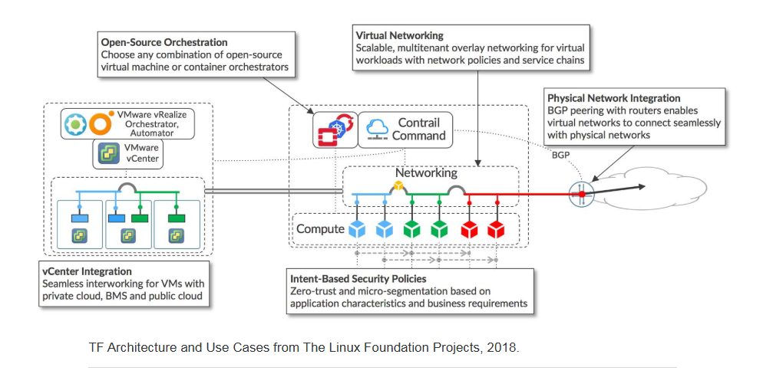

What TF (Tungsten Fabric) is (in one line)
Tungsten Fabric (TF) is an SDN-based virtual networking platform used to manage networking, security, and connectivity across cloud and data-centre environments.

Use cases (very briefly)
- Private cloud
TF manages network communication between VMware virtual machines.
- Public cloud
TF manages networking between VMs and containers running in the cloud.
- Physical switch integration
TF connects virtual networks to physical switches.
- Traditional data centres
TF integrates with routers in legacy data-centre networks.

Built-in networking features
Because TF originated from Juniper:
- DHCP, DNS, NAT
- IPv4 & IPv6 (dual-stack)
- Firewall and load balancing
- BGP for routing
👉 These features work out of the box (no extra products needed).

Wide-area connectivity
MPLS labelling is a forwarding technique where packets are assigned short labels that routers use to quickly switch traffic along predefined paths instead of performing IP lookups.
- Supports MPLS
- Connects:
  - private clouds
  - public clouds
  - hybrid environments
  - traditional data centres

One-sentence exam summary
Tungsten Fabric provides SDN-based virtual networking with built-in routing, security, and cloud integration, enabling seamless connectivity across private clouds, public clouds, and traditional data-centre infrastructure.
The core data plane controller is known as the vRouter, its architecture is shown in the figure below:
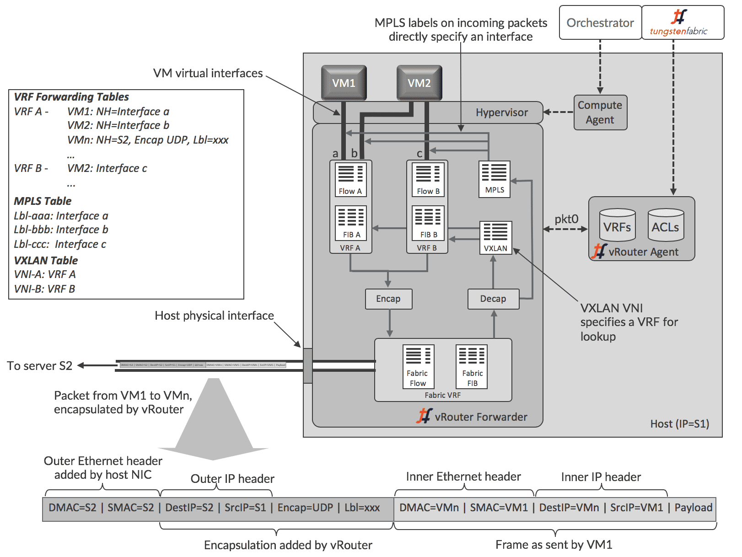
VRouter must be run on every node or host in the network and it natively supports MAC addressing, IP addressing or MPLS labelling. It has a number of VRFs (virtual routers and forwarders) - default two – that maintain their own copies of the FIB (forwarding information base) and routing tables passed down from the control plane. It also has its own MPLS (multi-protocol label switching) and VXLAN (virtual extensible LAN) tables so that it can process any packets it receives. It also receives ACL (access control lists) and filtering rules from the control plane.
As discussed previously the control plane has native controllers/ components that provide most standard network and filtering services (DHCP, firewall, DNS, etc) and pass rules down to the data plane via XMPP (extensible messaging and presence protocol).
The application plane hosts various software components depending upon the environment TF is used in.

If it is running in an OpenStack virtual cloud it would typically use Heat as the orchestration module; if its running in the public cloud it might use kubernetes and if it was running on a VMware stack it might use Vrealize.
A user also has the option of using the commercial contrail insights for monitoring and/or management or running an analytics package in another VM or container.

✅ 5-step revision flow (VM → VM via vRouter)
1️⃣ VM sends packet
- VM1 creates a normal Ethernet/IP packet for VMn.
2️⃣ vRouter receives packet
- Packet enters the vRouter data plane via a virtual interface.
3️⃣ VRF & FIB lookup
- vRouter selects the correct VRF
- Uses its FIB/flow tables (from control plane) to decide next hop.
4️⃣ Encapsulation (overlay)
- vRouter encapsulates the packet using MPLS or VXLAN
- Original packet remains unchanged inside.
5️⃣ Forward & decapsulate
- Packet leaves via physical NIC
- Travels across the fabric
- Destination vRouter decapsulates and delivers to VMn.

✅ MPLS vs VXLAN (in THIS diagram)

MPLS
- Uses a label
- Label directly maps to an outgoing interface
- Fast forwarding
- Common in service provider / data centre fabrics
👉 In diagram: MPLS label specifies interface

VXLAN
- Uses a VNI (VXLAN Network Identifier)
- VNI maps traffic to a VRF
- Better for large-scale multi-tenancy
- Common in cloud environments
👉 In diagram: VXLAN VNI specifies a VRF for lookup

🧠 One-line memory hooks
- MPLS → label → interface
- VXLAN → VNI → VRF
- Control plane decides, vRouter enforces

🎯 One-sentence exam answer
In a host-based SDN architecture, the vRouter forwards VM traffic by selecting a VRF, applying control-plane rules, encapsulating packets with MPLS or VXLAN, and transporting them across the physical fabric before decapsulation at the destination.

Future Internet Architectures
The architecture of the Internet today is in many ways the same as it was when it was first conceived over forty years ago.
However, its use over that period has changed dramatically:
Initially, it was designed as a remote access and networking research platform. Even the world wide web was designed initially as a research knowledge sharing network.
Today, its primary use is as a social networking and e-commerce hub, which means there are very different demands on the system.
The major limitations with the Internet today are that it is host centric, not content centric; it has no security design/ architecture; and it is difficult to expand or augment the existing architecture to fit todays requirements.
There have been a number of research projects that can generally be classed under the umbrella of Future Internet Architectures, plus a number of commercial and open source projects that have also tried to address some or all of the problems discussed above.
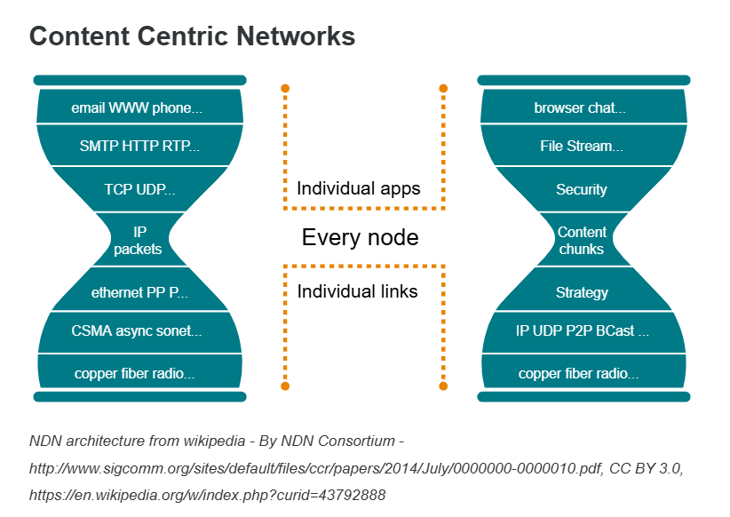
The first challenge, host centricity, is related to the fact that we still have to manage the internet as a collection of hosts and whereas the search engines have managed to index much of the content available we still need to access the host itself (in most cases) to access the content. The concept of Content Centric Networks (CCN) is not new, indeed many would argue that it is just putting in place the Xanadu project proposed by Ted Nelson in 1979. The two major initiatives in use today are Content Centric Networking (CCN), developed at Xerox Parc and documented by Edens & Scott, 2017.

The other is Named Data Networking (NDN) which is a development of the original CCN concept (see the figure for an architectural schematic). Both NDN and CCN use a concept of interest packets (i.e. requests for data) and content packets (which contain the requested data). Both systems have the option of encrypted requests and responses (NDN was reviewed in a paper by Ding et al, 2016).

Explanation:
Big idea of the image
The picture compares two ways of thinking about networking:
- Left side: the traditional layered network stack (how the Internet was built)
- Right side: a modern, application/content-focused view of networking
Think of it as “network-centric” vs “application/content-centric”.

LEFT SIDE — Traditional networking (layered model)
This is the classic networking stack, built from the bottom up.

Bottom → Top
- Physical media
  - Copper, fibre, radio
  - Actual cables and wireless signals
- Data link technologies
  - Ethernet, PPP, CSMA, SONET
  - Move frames on a local network
- Network layer
  - IP (Internet Protocol) packets
  - Responsible for addressing and routing
- Transport layer
  - TCP (Transmission Control Protocol), UDP (User Datagram Protocol)
  - Reliability, ordering, speed
- Application protocols
  - SMTP (email), HTTP (web), RTP (media)
  - Rules applications use to talk
- Applications
  - Email, web, phone
  - What users actually interact with
👉 Key idea:
The network mainly cares about packets and addresses, not what the content is.

RIGHT SIDE — Modern / application-centric networking
This side shows a shift in focus:
from “how packets move” → “what the application needs”.

Bottom → Top
- Physical media
  - Same as before: copper, fibre, radio
- Basic networking
  - IP, UDP, peer-to-peer, broadcast
  - Still there, but more flexible
- Strategy layer
  - Decides:
    - how data should flow
    - where it should go
    - how it should scale
- Content chunks
  - Data is treated as pieces of content
  - Not just packets between addresses
- Security
  - Built into the architecture, not added later
  - Authentication, encryption, trust
- Applications
  - Browser, chat, file streaming
  - Applications directly influence network behaviour
👉 Key idea:
The network understands content, intent, and security, not just packets.

What the dotted boxes mean
The dotted boxes highlight where abstraction changes:
- Traditional networking:
  - Strict layers
  - Each layer is isolated
- Modern networking:
  - Layers are more flexible
  - Decisions can be made higher up (closer to applications)

Why this shift happened
- Cloud computing
- Streaming media
- Microservices
- SDN (Software-Defined Networking)
- NFV (Network Functions Virtualisation)
Modern applications need:
- scalability
- security
- awareness of content
- faster changes

One-sentence exam-ready summary
The diagram contrasts traditional layered networking, which focuses on packet transport, with modern application-centric networking, which emphasises content, security, and application-driven network behaviour.

CCN and NDN:
The problem: host-centric Internet
Today’s Internet is host-centric, which means:
- To get information, you must contact a specific computer (host).
- Even if you know what content you want, you still need to know where it lives (the server).
Search engines help you find content,
but to access it, you usually still have to connect to the original host.
👉 The Internet focuses on locations (hosts), not content itself.

The idea: content-centric networking
Content-Centric Networking (CCN) changes this idea.
Instead of saying:
“Get this data from that server”
You say:
“Get this data, wherever it exists”
The network cares about what you want, not where it is stored.
This idea isn’t new. It’s similar to concepts proposed as early as 1979 by Ted Nelson in the Xanadu Project.

Two main approaches today
1️⃣ Content-Centric Networking (CCN)
- Developed at Xerox PARC
- Focuses on naming and retrieving content directly
- Requests are based on content names, not IP addresses

2️⃣ Named Data Networking (NDN)
- An evolution of CCN
- Uses the same core ideas but with architectural improvements
- Often shown with a clean, layered design (like in your figure)

How CCN and NDN work (very simply)
Both systems use two types of packets:
- Interest packets
  - Requests for specific content
  - “I want this data”
- Content packets
  - Carry the requested data back
  - Can come from any node that has a copy (cache, router, server)

Security
- Both CCN and NDN support encryption
- Requests and responses can be protected
- Security is tied to the content itself, not just the connection

One-sentence exam-ready summary
Content-centric networking shifts the Internet from host-based communication to content-based communication, using interest and content packets to retrieve data securely without requiring access to a specific server.

Overlay Networks

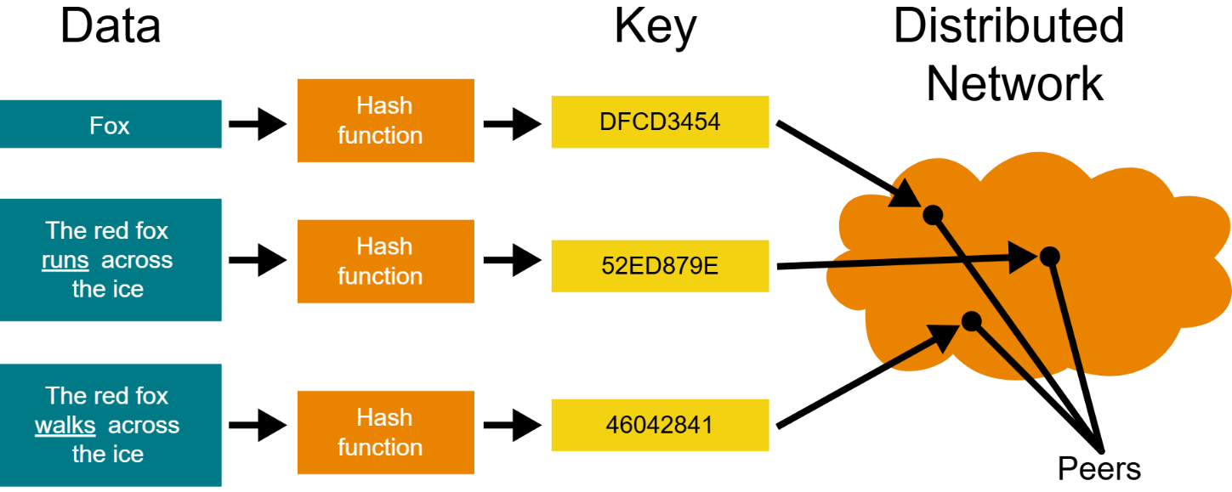
DHT diagram from Wikipedia
The next proposed solution is overlay networks. These take many forms from the widely spread CDNs, emerging technologies like SDNs and alternative, peer to peer technologies such as KAD, Freenet and TOR. Benefits include distributed systems, distributed management and also host agnostic content. CDNs and SDNs have been discussed in some detail in other sections so here we will focus on peer to peer overlays.

Most of the peer to peer overlay networks depend on a technology known as distributed hash tables (DHT) - see figure.

These allow a search string to be hashed and then used to search for content in a distributed network. It is even possible to initiate searches across open source, encrypted networks. Again the searches are network agnostic. Freenet is slightly different in that its main purpose is anonymity and preserving free expression, and the content is distributed and cached across every node that participates in the network. TOR (the onion router) is an alternative routing system that is designed to provide anonymity via encrypting messages and routing them via multiple anonymising relays. It also has an overlay network built from so called onion sites that can only be accessed via a TOR browser. These latter two systems form part of what is known as the Dark Web. Urdaneta et al, 2011 provides an extensive assessment of attacks against DHT based networks.
Simple explanation:
Big idea: overlay networks
An overlay network is a network that runs on top of the existing Internet, instead of replacing it.
- It uses the normal Internet underneath
- But adds its own rules for routing, searching, or security

Examples of overlay networks
Overlay networks come in different forms:
- CDNs (Content Delivery Networks) → faster content delivery
- SDN (Software-Defined Networking) → programmable networks
- Peer-to-peer (P2P) networks → users share data directly
This section focuses on peer-to-peer overlays.

Peer-to-peer (P2P) overlay networks
In P2P networks:
- There is no central server
- Every computer (node) can:
  - store content
  - search for content
  - forward requests
This makes the system:
- distributed
- resilient
- not tied to a specific host

Distributed Hash Tables (DHTs)
Most P2P overlays use Distributed Hash Tables (DHTs).
What a DHT does (very simply):
- A search term is turned into a hash value
- That hash is used to locate which node should have the content
- The request is routed through the network to that node
👉 No central index is needed.
Benefits:
- Scales well
- Works even if nodes join or leave
- Searches are network-agnostic (not tied to one server)

Special P2P overlay examples
Freenet
- Focuses on anonymity and free expression
- Content is:
  - encrypted
  - distributed
  - cached across all participating nodes
- No one node knows where content originated

TOR (The Onion Router)
- Designed to provide strong anonymity
- Messages are:
  - encrypted multiple times
  - routed through several relay nodes
- Also supports onion sites, which:
  - are only accessible via the TOR browser
  - form part of the Dark Web

Security note
- DHT-based networks can be attacked (e.g. routing manipulation, poisoning)
- These risks have been widely studied in academic research

One-sentence exam-ready summary
Overlay networks run on top of the Internet to provide distributed, host-agnostic content access, with peer-to-peer overlays using distributed hash tables to locate data, and systems such as Freenet and TOR focusing on anonymity and censorship resistance.

Fog/Edge Computing

Real-World Example of Fog Computing

Smart Traffic System in a City
Imagine a modern city with:
- Traffic cameras
- Road sensors
- Smart traffic lights
- Connected cars

Without Fog Computing (Cloud Only)
- Camera detects heavy traffic
- Sends data to a cloud data centre
- Cloud analyses traffic
- Sends instructions back
- Traffic light changes
❌ Problem:
- Delay (latency)
- Network congestion
- If internet fails → system fails

With Fog Computing (Better Design)
- Camera detects heavy traffic
- Data is sent to a nearby fog node (local mini data centre at an intersection)
- Fog node processes data instantly
- Traffic light timing is adjusted locally
✅ Result:
- Very low latency
- Faster decisions
- Less internet bandwidth used
- Works even if cloud connection drops

Where everything sits
- Edge → Cameras and sensors
- Fog → Local traffic control server (near intersection)
- Cloud → Central city management system

Why this is Fog (not just Edge)
- Processing is not only inside the camera
- It’s done at a local intermediate node
- That node supports many devices in that area
That middle layer = Fog computing

🚗 Another Example (Automotive)
In connected vehicles:
- Car sensors = Edge
- Roadside processing unit = Fog
- Manufacturer cloud analytics = Cloud

🎯 Simple Definition
Fog computing is a layer of local computing between edge devices and the cloud that provides fast processing and storage close to users or sensors.
The movement of processing (and applications) from a centralised cloud model to a more localised fog/edge model is also known as osmotic computing.

5G (MobilityFirst)
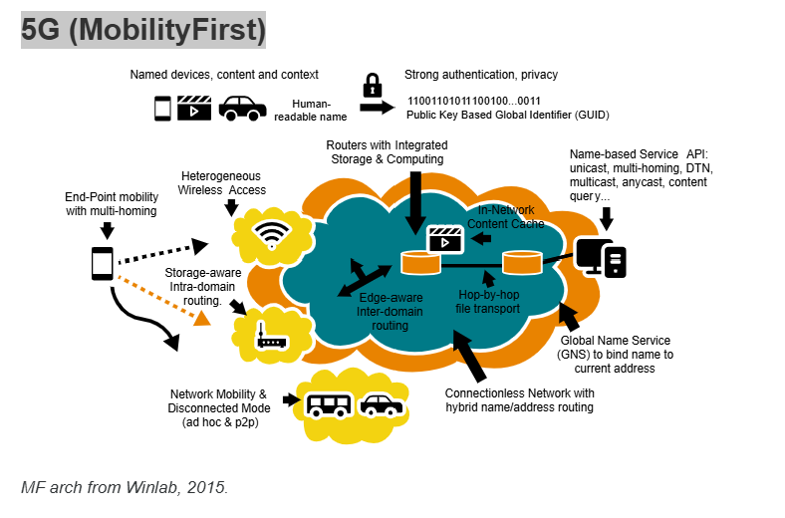

📦 What the diagram shows (simplified)
The picture highlights:
- Named devices, content, and context
- Strong authentication
- Public key–based identity
- Edge-aware routing
- In-network content caching
- Multi-homing (multiple connections at once)
- Hybrid name/address routing
It combines ideas from:
- Content-Centric Networking (CCN)
- Overlay networks
- Fog computing
- Software-Defined Networking (SDN)
- Network Functions Virtualisation (NFV)

📱 Why this matters for 5G
MobilityFirst is useful for:
- Mobile devices
- Autonomous vehicles
- Internet of Things (IoT)
- 5G cellular systems
Because it:
- Handles mobility natively
- Improves security (identity-based)
- Supports multi-network connectivity
- Allows disconnected operation

🔐 Security improvement
Because GUIDs are created from public keys:
- Identity is cryptographically verifiable
- Spoofing becomes harder
- Security is built into architecture (not added later)

🎯 One-sentence exam-ready summary
MobilityFirst is a future Internet architecture that separates identity from location using globally unique identifiers (GUIDs), enabling secure, mobility-aware communication and improving flexibility for mobile and 5G networks.

🌐 What is MobilityFirst (MF)?
MobilityFirst is a proposed future Internet architecture designed to fix major weaknesses of today’s Internet.
It started around 2010 and is still an active research area.

🚨 What problems is it trying to fix?

1️⃣ Identity vs Address confusion
In today’s Internet:
- A device has:
  - An identity (who it is)
  - An IP address (where it is)
But IP address = identity + location at the same time.
When a mobile device moves:
- Its IP address changes
- Connections break
- Sessions must restart
👉 The Internet was not designed for constant mobility.

2️⃣ Weak security design
Current Internet security:
- Was added later (not built in)
- Radio encryption and network protocols are separate
- Many security gaps exist in cellular systems

3️⃣ Lack of flexibility
Today:
- Switching from WiFi to cellular often drops connections
- Moving between networks interrupts communication

🧠 Core idea of MobilityFirst
MobilityFirst separates:
- Identity (who you are)
from
- Location (where you are)

🔑 How it works

GUID (Globally Unique Identifier)
Every device gets a:
GUID = Globally Unique Identifier
- It never changes
- It represents identity only
- It is created from a public key
- Therefore, it is cryptographically secure
Even content can have a GUID.

GNS (Global Name Service)
The Global Name Service (GNS):
- Maps the GUID to a current network address
- Keeps track of where the device currently is
So when a device moves:
- GUID stays the same
- Only the network address changes
- Communication continues

In today’s Internet (IP-based)
If you:
- Disconnect from Wi-Fi
- Connect to 5G cellular
Your IP address changes.
Because:
IP address = identity + location
So when the address changes:
- Ongoing sessions break
- You may need to reconnect
- TCP sessions often reset

In MobilityFirst (MF)
You have:
- GUID (Globally Unique Identifier) → permanent identity
- Network Address (NA) → current location
When you switch from Wi-Fi to 5G:
- ✅ Your GUID stays the same
- 🔄 Only your Network Address changes
- 🔁 The Global Name Service (GNS) updates the mapping
So communication can continue without restarting from scratch.

So would there be zero disruption?
In theory:
- The session should continue
- The system reroutes traffic using the new address
- No need to change identity
In practice (real-world implementation):
- There might be a very small delay
- But no full session break like in traditional IP
References
Page 1 of 2
University of Essex Online Page 1 of 2
References
Bandos, T. (2019) The Five Steps of Incident Response. Available from:
https://digitalguardian.com/blog/five-steps-incident-response [Accessed 1 March 2022]
Berger (2021) What is Log4Shell? The Log4j vulnerability explained (and what to do about it). Available
from: https://www.dynatrace.com/news/blog/what-is
log4shell/?utm_source=google&utm_medium=cpc&utm_term=log4j%20vulnerability%20explained&utm
_campaign=uk-applicationsecurity&utm_content=none&gclid=CjwKCAjwiuuRBhBvEiwAFXKaNJd3hLzYlujXuVbTIP63_IioBFvzAY
OePxfft2D6ded7EXfaTu4j4BoCrHAQAvD_BwE&gclsrc=aw.ds [Accessed 1 March 2022]
Bhingardeve, N. & Franklin, S. (2018) A Comparison Study of Open Source Penetration Testing Tools.
International Journal of Trend in Scientific Research and Development. 2(4). 2595-2597.
Ding, W., Yan, Z. & Deng, R. (2016) A Survey on Future Internet Security Architectures. IEEE Access.
Eaton, I. (2003) The Ins and Outs of System Logging Using Syslog. Available from:
https://www.sans.org/reading-room/whitepapers/logging/ins-outs-system-logging-syslog-1168
[Accessed 17 June 2020].
Kent, K. & Souppaya, M. (2006) Guide to Computer Security Log Management. Available from:
https://csrc.nist.gov/publications/detail/sp/800-92/final [Accessed 17 June 2020]
Leroux, S. (2020) The Kali Linux Review You Must Read Before You Start Using It. It's FOSS. Available
from: <https://itsfoss.com/kali-linux-review/> [Accessed 2 June 2020].
Schwartz, P. & Janger, E. (2007) Notification of Data Security Breaches, Available from:
https://repository.law.umich.edu/mlr/vol105/iss5/2 [Accessed 1 March 2022]
Swinhoe, D., (2020) The 15 Biggest Data Breaches of the 21st Century. [online] CSO Online. Available
from: <https://www.csoonline.com/article/2130877/the-biggest-data-breaches-of-the-21st-century.html>
[Accessed 2 June 2020].
Page 2 of 2
University of Essex Online Page 2 of 2
Swift, D. (2010) Successful SIEM and Log Management Strategies for Audit and Compliance. SANS
Information Security Reading Room. Available from: <https://www.sans.org/readingroom/whitepapers/auditing/successful-siem-log-management-strategies-audit-compliance-33528>
[Accessed 8 June 2020].

This is the End

